

**Superior University**

**Sargodha Campus**

**PROJECT REPORT:**

**Secure Bank Network Design**

**Project Participants:**

**Name: Roll number:**

Zulqarnain Ali Natiq SU72-BSITM-S23-004

Abu-Umama Zulfiqar SU72-BSITM-F22-009

**Detailed Report:**

**Bank Network Design & Implementation Using Cisco Packet Tracer:**

**Project Overview:**

This project involves designing and implementing a comprehensive banking network system using Cisco Packet Tracer. The network is designed to support enterprise-level requirements with robust security and efficient network management features. This report details the steps taken, technologies implemented, and the rationale behind various configurations.

**Objective:**

The primary objective of this project is to design and simulate a banking network that ensures efficient data flow, security, and network scalability. The network includes functionalities such as VLANs, inter-VLAN routing, DHCP, port security, SSH access, and WLAN configurations.

**Configuration Steps:**

* Basic settings to all devices plus ssh on the routers and 13 switches.
* VLANs assignment plus all access and trunk ports.
* Switchport security to all 12 switches.
* Subnetting and IP addressing
* OSPF on the routers and 13 switches.
* Static IP address to serverRoom devices.
* DHCP server device configuratiuons.
* Inter-VLAN routing on the 13 switches plus ip dhcp helper addresses.
* Wireless network configurations.

**Network Design:**

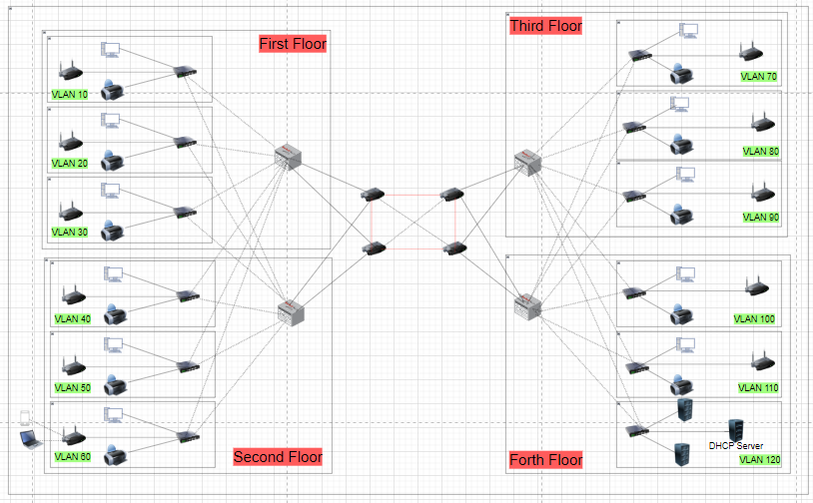 **(Network Design on Draw.io)**

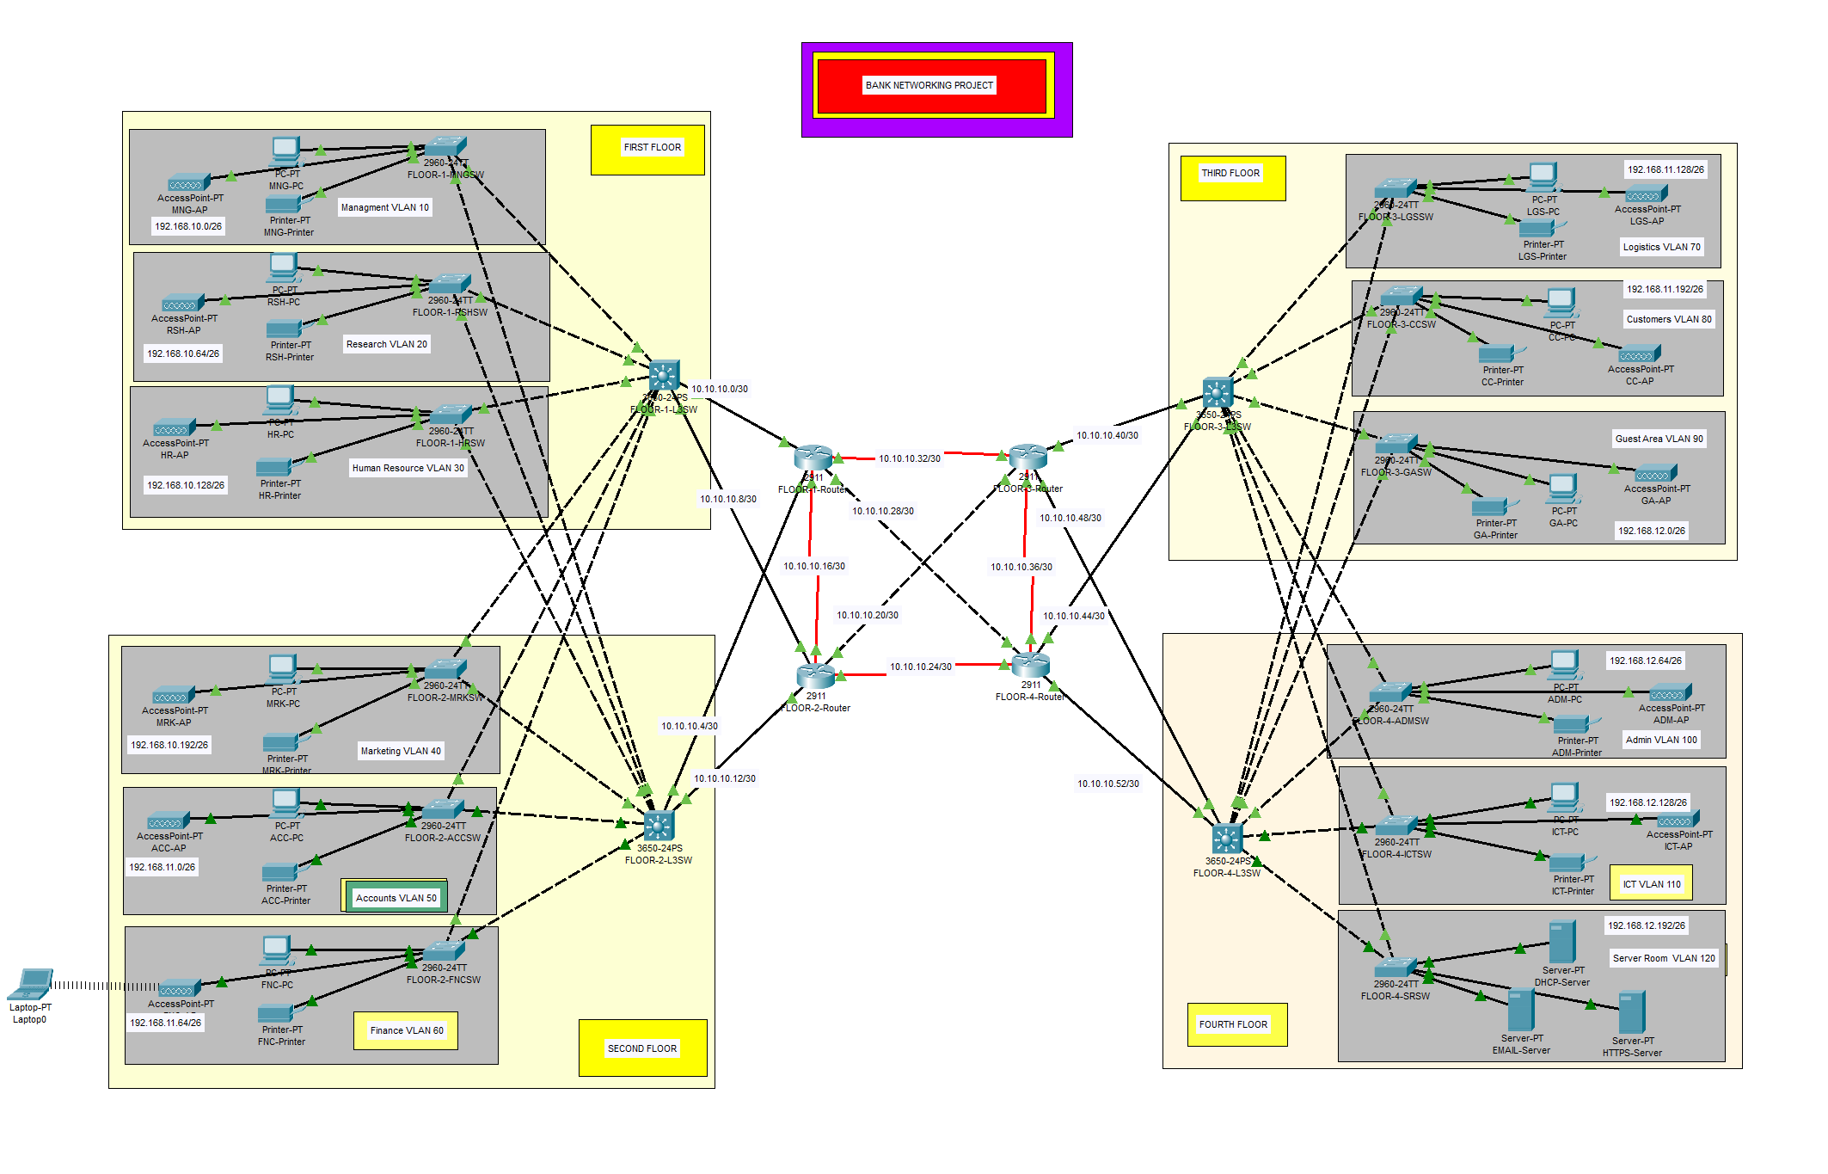(Topology Design on Packet Tracer)

**Technologies Implemented:**

1. **VLANs (Virtual Local Area Networks):**
   * VLANs were used to segment the network into logical groups to enhance security and manageability. Different VLANs were created for various departments within the bank, such as “Teller VLAN”, “Admin VLAN”, and “Guest VLAN”.
2. **Inter-VLAN Routing (SVI – Switch Virtual Interface):**
   * Configured SVIs to allow communication between different VLANs. A Layer 3 switch was used to route traffic between VLANs, ensuring seamless inter-departmental communication.
3. **DHCP Server Configuration:**
   * A centralized DHCP server was set up to dynamically assign IP addresses to devices within the network, ensuring efficient IP management and reducing administrative overhead.
4. **Port Security:**
   * Port security was configured on switches to prevent unauthorized access and mitigate MAC address flooding attacks. This ensures only known devices can connect to the network ports.
5. **SSH (Secure Shell) Configuration:**
   * SSH was enabled for secure remote management of network devices. This ensures encrypted communication when accessing network devices for configuration and monitoring.
6. **WLAN Configuration:**
   * Access points were configured to provide wireless connectivity for employees and guests. The WLAN was secured with WPA2 encryption to protect data transmissions.
7. **Host Configurations:**
   * Devices, including PCs and laptops, were configured with appropriate IP addresses and network settings. Each device was assigned to the appropriate VLAN to ensure proper network segmentation.

**Switches:**

There are total 16 switches used in my project.

L3SW means layer 3 switches

FLOOR 1

* MNGSW means managment switch
* RSHSW means Research switch
* HRSW means Human Resource switch

FLOOR 2

* MRKSW means marketring switch
* ACCSW means Accounts switch
* FNCSW means Finance switch

FLOOR 3

* LGSSW means Logestics and store switch
* CCSW means Customer Care
* GASW means Guest Area switch

FLOOR 4

* ADMSW means Administration switch
* ICTSW means ICT switch
* SRSW means server Room switch

Password for every switch is “cisco”

IP-Domain Name: “cisco.net”

**Detailed Steps and Configurations:**

1. **Network Topology Design:**
   * A comprehensive topology was designed featuring core switches, access switches, routers, and wireless access points.
   * The design included redundant links to ensure high availability.

2. **VLAN Creation:**

* Commands used for VLAN creation on switches:

Switch(config)# vlan 10

Switch(config-vlan)# name TELLER_VLAN

Switch(config)# vlan 20

Switch(config-vlan)# name ADMIN_VLAN

3. **Inter-VLAN Routing Setup:**

* SVIs were created on a Layer 3 switch with IP addresses assigned to each SVI for inter-VLAN communication:

Switch(config)# interface vlan 10

Switch(config-if)# ip address 192.168.10.1 255.255.255.0

Switch(config)# interface vlan 20

Switch(config-if)# ip address 192.168.20.1 255.255.255.0

4. **DHCP Server Configuration:**

* The DHCP server was configured with the necessary pool settings:

ip dhcp pool ADMIN_POOL

network 192.168.20.0 255.255.255.0

default-router 192.168.20.1

5. **Port Security Configuration:**

* Port security was applied to specific ports to limit the number of allowed MAC addresses:

Switch(config-if)# switchport port-security

Switch(config-if)# switchport port-security maximum 2

Switch(config-if)# switchport port-security violation restrict

6. **SSH Configuration for Secure Access:**

* Commands for enabling SSH:

Switch(config)# ip domain-name banknetwork.local

Switch(config)# crypto key generate rsa

Switch(config)# username admin secret password123

7. **WLAN Configuration:**

* Configured the access points with SSIDs and secured them using WPA2:

AP(config)# ssid BANK_EMPLOYEES

AP(config-ssid)# wpa2 passphrase securepass

**Devices for each floor:**

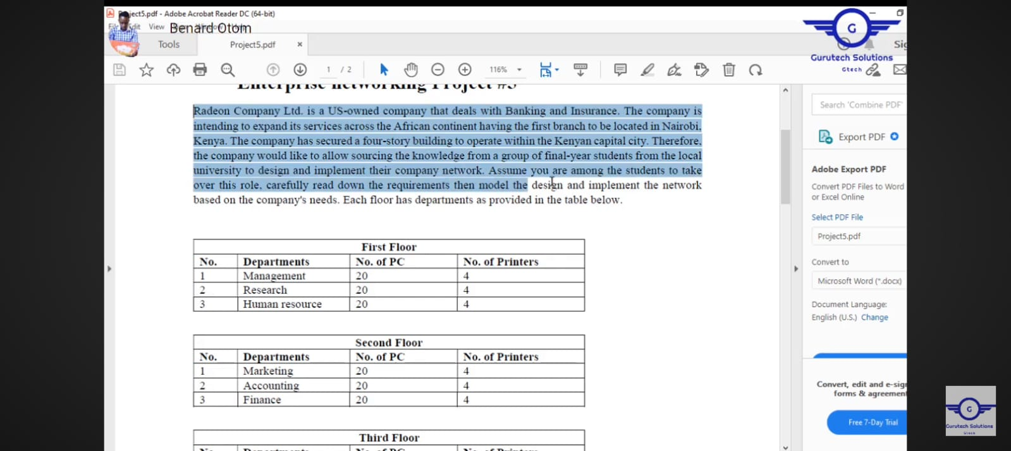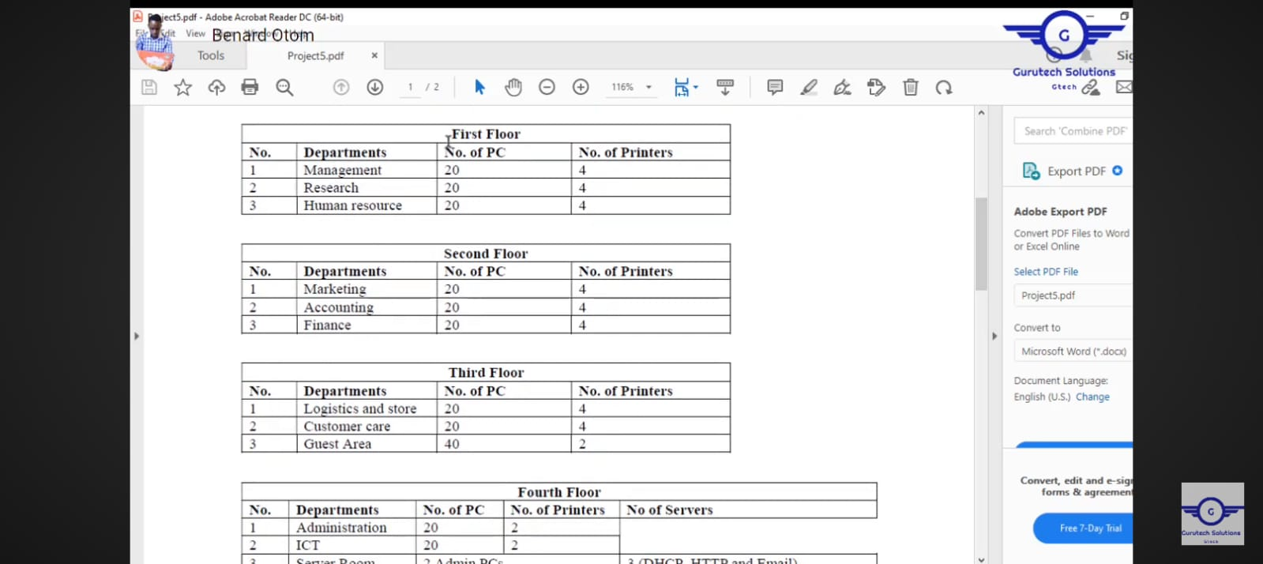

**Base IP Address: 10.10.10.0**

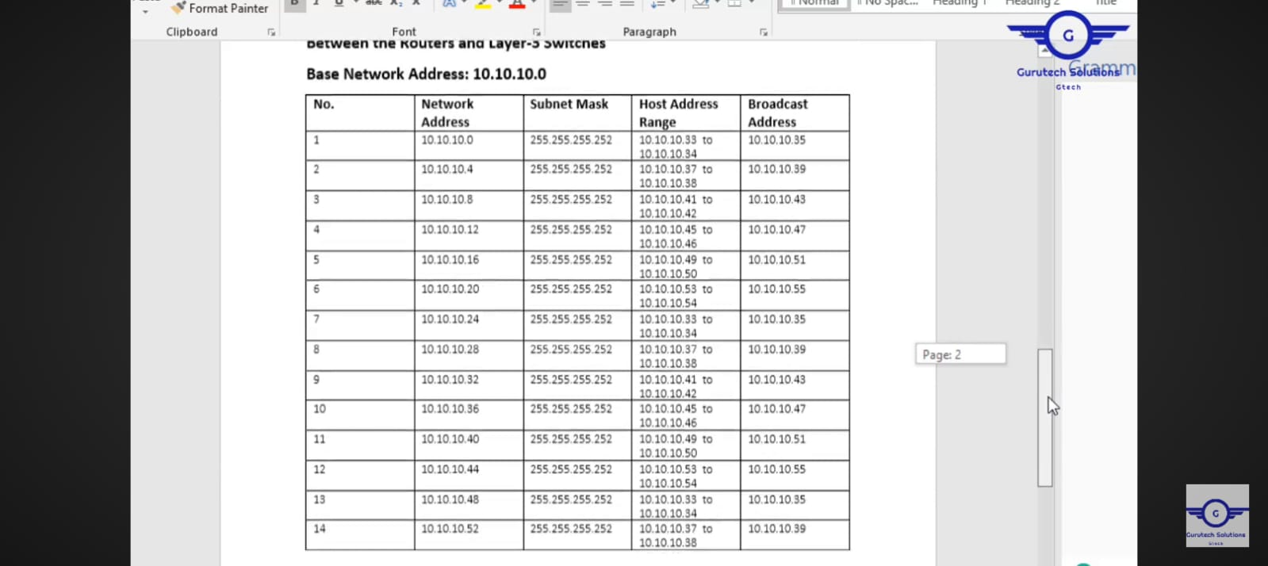

**Conclusion:**

This project successfully implemented an enterprise-level banking network using Cisco Packet Tracer. The network design and configurations focused on scalability, security, and efficient network management. Key features such as VLANs, inter-VLAN routing, DHCP, port security, SSH, and WLAN were meticulously integrated to meet the bank’s operational requirements.